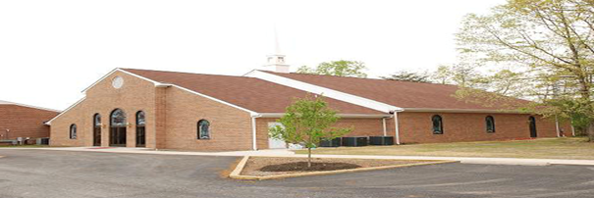
Ebenezer Baptist Church, Beaverdam, VA
Notes from the Pastor
November 2025
The “powers” of this world have cast a shadow of deceit, division, destruction, and darkness across our local, national, and global communities and even Mother Earth is groaning. Regrettably and tragically, major, and multiple segments of the Christian church are condoning and celebrating the darkness rather than walking in the light that shines in the darkness and can never be extinguished. Because the light still shines, even though we walk through the valley of the shadow of death, we will fear no evil because God’s Presence, Provision, Protection, and Promises are sure. As we walk in these assurances, every day is a day of Thanksgiving!
During the month of November, our sermonic messages will be developed from selected psalms. The Book of Psalms, written by many authors and composed over many years is the hymn and prayer book of the people of Israel. Often quoted by Jesus and often cited in the New Testament, the Psalms have emerged as central to Christian meditation and worship. The 150 psalms are grouped into five books and may be identified through as many as ten typologies. In this season, you will hear five messages developed from each of the five books in the Book of Psalms.
November 2 Women’s Weekend-Rev. Lakeisha Cook
November 9 Book I- Psalms 1-41- “A Change Is Coming”- Psalm 7:10-17-
Veteran’s Day Recognition
November 16 Book II- Psalms 42-72- “Listen My People”- Psalm 50:7-15- Missionaries Anniversary and Harvest Baskets-Youth Church
November 17 Senior Mid-day Bible Study at 11 am
November 19 Book III- Psalms 73-87- “Now Is the Time”- Psalm 79:5-13- (Wednesday-Virtual- 7 p.m.)
November 22 Leadership Advisory Meeting - 10 am
November 23 Book IV- Psalms 90-106- “A Mighty God”- Psalm- 95:1-7-
Ushers’ Anniversary
November 26 Book V- Psalms 107-150- “Everybody Ought to Praise”-
Psalm 107:1-8- (Fast Day- Virtual Pre-Thanksgiving Worship-
7 p.m.)

With an attitude of gratitude, Let Us Give Thanks!
Rev. Kinney

