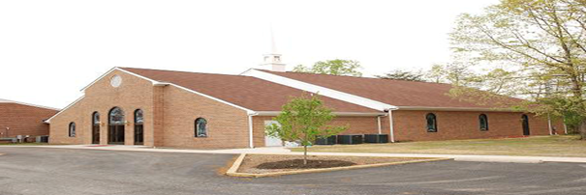
Ebenezer Baptist Church
Black History Month
Black to the Future- Isaiah 51:1-3

We are once again in a season where there is a concerted and unrepentant effort to erase the Black story and minimize the significant contributions of the children of Africa to this nation and our world. We cannot become so drunk with the wine of this world nor deceived by the calculated lies of this world that we forget and neglect the powerful and transformative gifts of our ancestors. We must never abandon the God of our ancestors who compels a commitment to the care of the earth and each other, while guiding us in the way that leads to justice for all.
While some would seek to deny our story, this is our Sankofa moment where we go back and fetch the truth that we are in danger of losing. We recenter, remember, reclaim, revision, and rejoice and in doing so, we resist. Through faithful word, witness, and work, we partner with all God’s children in celebrating the gifts of our diversity and the promise of our shared destiny. As we go back, we go Black and find the Spirit, wisdom, and resources of our ancestors and offer ourselves for the healing of the world and the nations. Held in the hollow of the Creator’s hand, we Lift Every Voice and Sing “may we forever stand, true to our God and true to our native land.” Seeing the light of a new day dawning, “let us fight on until victory is won.”
February 1 “Understood” Isaiah 51:1-3 –Welcome all to the Family
February 8 “Yes We Can” Judges 6:11-16
February 15 “Trouble in My Way” Joshua 6:1-5
February 18 Ash Wednesday - In person Bible Study- “Sanctify Yourself” Joshua 7
February 22 “Take It All Off” John 11:38-44
The Light is shining in the darkness, and the darkness cannot put it out. Walk in the Light and absorb the Light and reveal the brightness of Blackness.
Rev. Kinney

