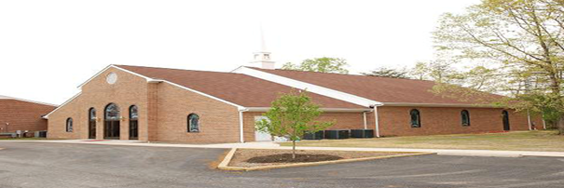
Ebenezer Baptist Church, Beaverdam, VA
Notes from the Pastor
January 2026

Restoring the Creation Mix - A True Fix in 2026
Our Theme: “Walk Together Children”- Ephesians 4:3-6,15,16

Basking in the light of Christmas that cannot be extinguished, we celebrate a New Year and recommit to a faithful walk with God. As we invest in this journey, we seek to honor the design, desire, and intent of the Creator for communion and harmony in every aspect of Creation. In the beginning we lived in a harmonious relationship with God, our authentic sacred selves, each other, mother earth, and the rest of the cosmos. But, in the beginning, we also encounter disruptive forces that seek to break the relational unity in Creation. These disruptive forces sow seeds of deception that invite us to separate from God, our true selves, each other, and the earth from which we came.
Falling for the tricks of the “father of lies,” we have normalized and institutionalized separation, domination, and division and brought death and destruction to a world created for flourishing. The forces of darkness exposed in the beginning remain active and seek seats in high places so they can spew their venom so that life in the garden of earth can be partitioned, polluted, poisoned, and petrified. Significant elements of the “church” have sacrificed the transformative truth of God revealed in Jesus Christ for cultic and cultural promotion and supremacy, In times like these, we must renew our commitment to be agents of remembrance, revisioning, and reconciliation as we seek to be a people fulfilling the vision of God in the beginning and embodied in the healing presence of Jesus Christ. At EBC, rather than being captured by suicidal domination, division, and destructive competition, we will live the fix in twenty-six. Walk together children and don’t you get weary!
January 4 “All in God’s Hands”- Ephesians 1:3-6,15,16
- Baptism 9:45
- Keep It 100 Offering
January 11 “Family Matters”- Genesis 37:18-36; 50:18-21
January 18 “What Are You Going to Do”- Romans 12:10-21
-Confirmation of Leaders
-Light refreshments after morning service followed by our Annual Congregational Meeting
January 25 “When We All Get Together”- Revelation 7:9-17
May the “unbroken circle” be the standard of our present living and not just the vision of our future Glory.
Rev. Kinney

